The Friarage Summer Challenge
Dear Parent/carer,

We would first of all like to thank you for all of your efforts regarding the home learning work which has been sent out in recent weeks. The response we have received has been overwhelming and we are exceptionally proud of how hard the children have been working from home. This week we have decided to not send out our home learning sheets and instead launch our Friarage summer challenge. The challenge consists of lots of fun and engaging activities that you can complete with your child over the summer holidays. It would be great if you could record on the sheet the challenges that you have completed and return it to school on the first day back in September.
Build a den (indoors or outdoors).  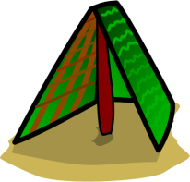 | Bake a cake. | Have a day without any electronics. (Ipads, computers, phones, cameras). | Design your own superhero and make a comic about them. | Leave a nice message in the street for the postman or the bin men using chalk.
Go on a mini beast hunt. | Make a kite and fly it.  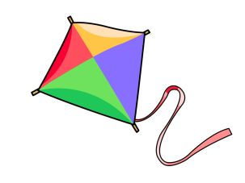 | Make your own musical instruments. | Visit the beach.  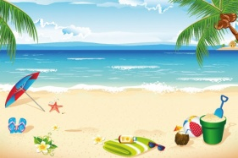 | Write a letter or postcard to a friend and post it.  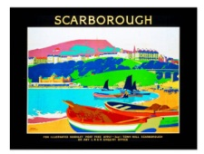
Make shadow pictures in the sun.  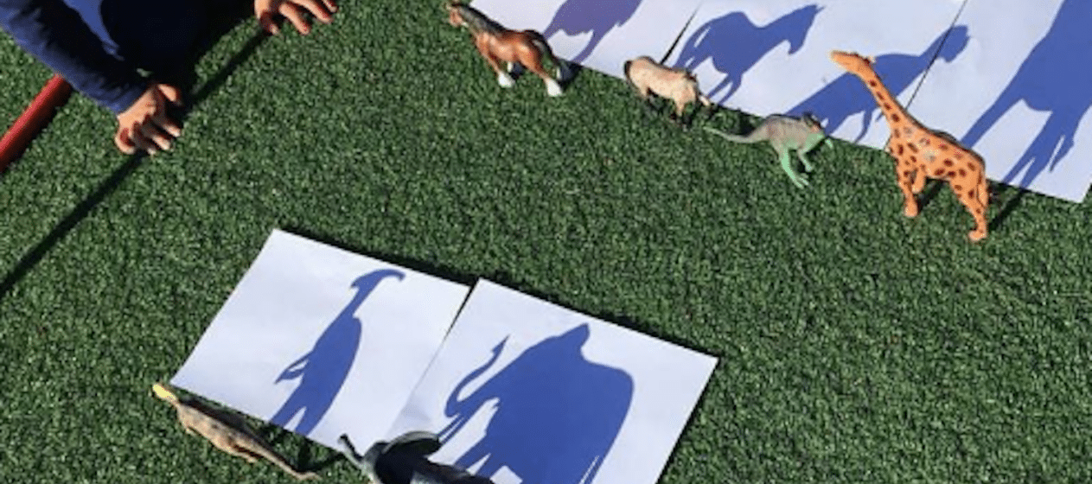 | Practise your skipping. | Learn how to say 5 words in a different language. | Go on a treasure hunt – what exciting things can you find?.  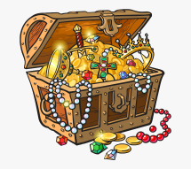 | Decorate a rock and leave it for someone to find.  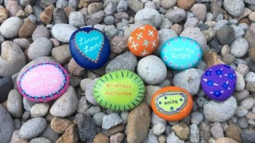
Build as many sandcastles as you can.  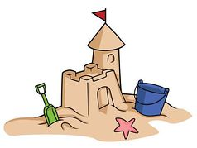 | Random act of kindness – do something to make someone simile. | Explore a rock pool.  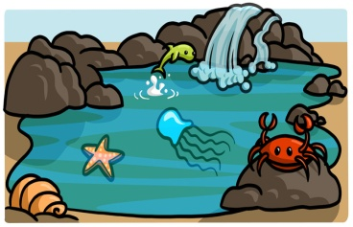 | Buy some seeds and see if you can grow some fruit or vegetables.  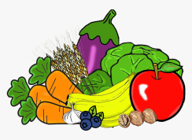 | Learn how to do a magic trick.
Design a treasure map.  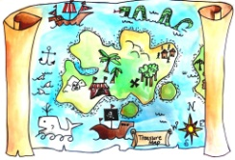 | Make a robot out of your recycling waste.  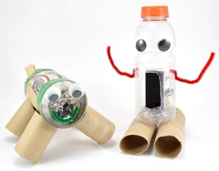 | Listen to / sing a song that makes you happy. | Visit a forest or woodland.  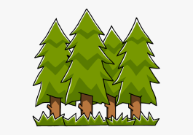 | Make your own play dough.  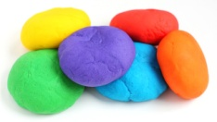
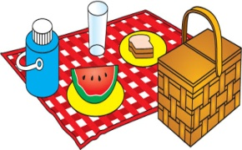  Go for a picnic. | Learn how to do a cartwheel | Make an egg protector, put an egg in it, drop it out the window and see if your egg protector worked.  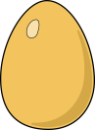 | Make a boat and see if it floats in water. | Make something using origami.  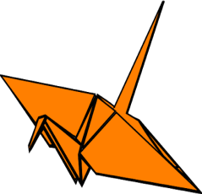
Chop some fruit and make a fruit salad.  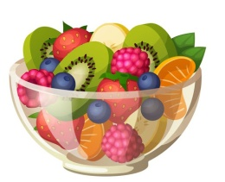 | Dance to your favourite song. | Read a book in the sunshine. | Make a scrapbook of your summer adventures.  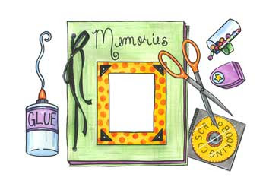 | Go for a walk and draw a map of your route.  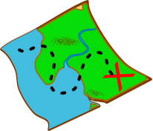
Paint or draw a picture. | Make some jewellery out of pasta.  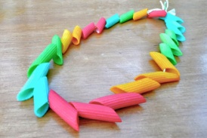 | Make a finger puppet  .  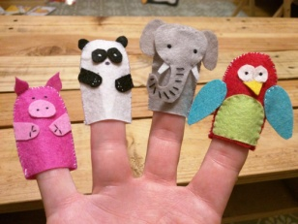 | Play a game of football. | Make a bird feeder.  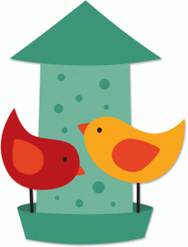

Have a fantastic summer break.
We look forward to welcoming you back in September

Please see the North Yorkshire link for further summer provision in and around the local area.
https://northyorkshireconnect.org.uk

