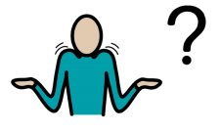Why might my child need counselling?

They may have:

* Anxiety
* Mild Generalised Anxiety Disorder
* Panic attacks
* Bereavement
* Depression (mild/moderate)
* Self-esteem issues
* Anger issues (mild/moderate)
* OCD (mild/moderate)
* Autism
* ADHD
* PTSD

What is Community Counselling?

* Support for pupils aged 9-16 with mild to moderate levels of emotional and psychological distress.
* It is completely free!

How do we refer?

* Arrange a chat with Miss Tymon (The SENDCo) on 01723 374 244. She is happy to help!
* Refer directly online:

[www.community-counselling.org.uk/children-s-service-referral-form](http://www.community-counselling.org.uk/children-s-service-referral-form)

Where are the sessions?

* 1-1 sessions will be held at The Street.

* Group sessions will be held at school.