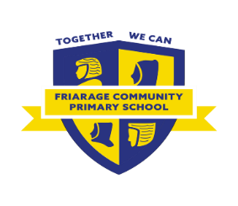

Who can I speak to about this?

* Their teacher
* The SENDCo, **Miss Tymon**. Please ask the office to book a meeting.
* Your GP, who can also make a referral.
* You can also make a referral here: <https://cyps.northyorks.gov.uk/childrens-therapy>

What help will they get? 

* They will assess your child and if they feel it is necessary, they will make a plan to help with their speech, language and communication difficulties.

NHS Speech, Language and Communication Support

I need more support?

* Contact SENDIASS: <http://sendiassnorthyorkshire.co.uk/>

What is it?

* They are speech and language therapists that can support your child.
* They will find out what they can do and what they find difficult.

Why do you want to refer my child to them?

* To support your child.
* To support staff understand your child’s needs and plan effectively.
* To support you.