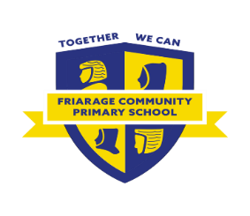

Who can I speak to about this?

* The SENDCo, **Miss Tymon**. Please ask the office to book a meeting.
* Speak to the Local Authority. Contact the SEN Admin team on 01609 535002 or [sen@northyorks.gov.uk](mailto:sen@northyorks.gov.uk)

What is it?

* A more detailed assessment of your child’s needs.
* It will help the school to support your child more fully.
* It will join up planning from education, health and care services.
* Once sent off, it takes 16 weeks to get a decision.

What help will they get? 

* If the Local Authority agrees, your child will receive an EHCP.
* An EHCP is a legal document which details your child’s needs and the support they should get.
* You can request where you would like your child to attend school, usually they stay at the same school.
* If your child is not given an EHCP, we might be signposted to other areas of support.

I need more support?

* Contact SENDIASS: <http://sendiassnorthyorkshire.co.uk/>

Education, Health and Care Assessment Request (ECHAR)

Why do you want to refer my child to them?

* You may request an EHCAR to be submitted.
* Your child may have not made good progress, despite support being put in place.
* We may feel your child needs a more detailed assessment of their needs.