Home reading
Dear Parents/Carers,

Reading at home with your child regularly really helps them to make progress. This letter explains what you will find in your child’s reading folder.

Please make sure that your child brings their reading folder to school every day and that all books are returned. If you need a replacement book bag these can be purchased from the school office.

Your child has completed our school phonics programme so will take home a short reader (labelled brown) or when ready they will choose a free reader from the library:

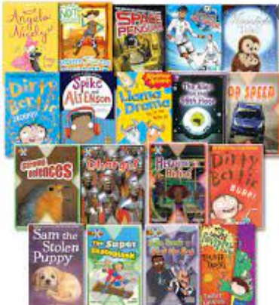
These books are at a suitable reading level for your child in order to practise their fluency and comprehension skills. Please encourage and support your child to read at home as often as possible.

Your child will also have the opportunity to regularly choose a library book
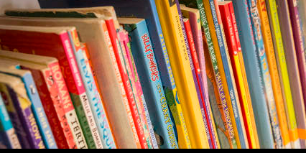
This is a book chosen for reading for pleasure. Your child might choose a non-fiction book that interests them, a joke book to make them laugh or a picture book that reminds them of being younger. The main objective of this book is to enjoy reading and sharing books together!

Please enjoy sharing books with your child as much as you can!

Thank you for your support.

