Reading
Reading is at the heart of our school and our whole curriculum. From the moment children enter our school, they are exposed to a wealth of high-quality texts and engaging reading experiences, feeding their imagination and instilling a lifelong love of reading.
Intent | The intent behind our approach to Reading is:  - To promote a love of reading, through teacher knowledge of high quality texts used across the curriculum.  - For children to obtain a word reading knowledge alongside comprehension skills in order to navigate texts and deepen their understanding of the world.  - To ensure that every child learns to read to a high standard of fluency and understanding, regardless of their background, needs or prior attainment.  - Close the ‘word gap’ by expanding pupils' vocabulary, deepening their understanding of the texts they are reading and widening their use of spoken language.
Implementation | Reading is at the heart of our school and alongside our robust phonics scheme the skills of early language are taught as soon as children start our school.  In EYFS adults will consistently model language, vocabulary and syntax both from books and stories, as well as throughout the day in play through our in the moment approach to teaching and learning. Children develop their own narratives and stories using helicopter stories and drawing club. Children in nursery have their ‘super 6’ stories which they explore and grow to know and love throughout the year.  In Reception and KS1 children receive a daily 20 minute storytelling time based on the Ruth Miskin ‘Talk for Stories’ programme. Children explore characters, plots, settings and themes followed by a 10 minute vocabulary session where tier 2 language is explicitly taught. This vocabulary is strategically modelled and applied across the day and revisited throughout the year.  Our talk for stories structure is:  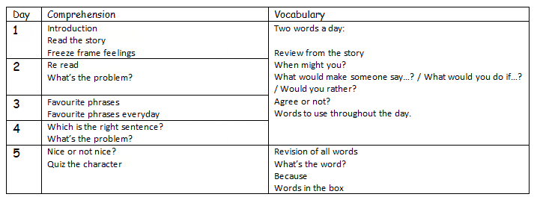  Children are exposed to a range of poetry and learn to love some favourite poems by heart with our poetry baskets.  Comprehension skills are developed in elements of the RWI sessions in EYFS and KS1 as teacher’s model ‘thinking about the story’ and children answer comprehension questions on their group text.  Whole class reading lessons start from Year 2 onward. The lessons provide a clear structure and sequence, and are based on the David Reedy and Wayne Tennent approach to reading as outlined in their book: Guiding Readers. The weekly reading structure includes questioning, clarifying, background knowledge, prediction, summarising and visualisation. We have a strong focus on vocabulary. Children also practise answering looking (retrieval), clue (inference) and thinking questions.  Texts are chosen to ensure coverage of fiction, non-fiction, picture books, poetry, video and audio comprehension. Children are exposed to a broad range of genres and authors both ‘Old and Gold’, and 'New and Bold’, allowing our children to become ‘Rounded Readers’. Our reading sessions are creative, innovative, engaging and highly interactive, providing children with opportunities to debate, discuss and analyse texts with their peers.  SEND and EAL children are supported to access lessons, through the use of Widgit word mats, word finding, cloze procedures and amended comprehension questions focusing on retrieval initially. Additional support is provided through access to RWI and Fresh Start groups through the week.  Our whole class reading lesson structure in Year 2 is:  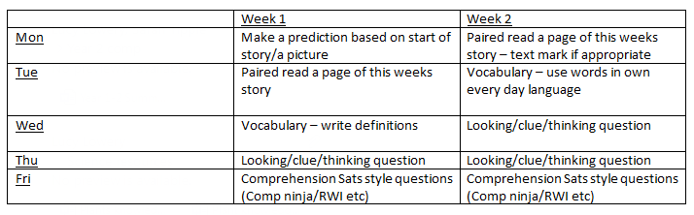  Our whole class reading lesson structure in KS2 is:  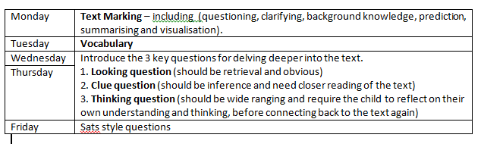  We assess children regularly through RWI assessments whilst learning to read and then PIRA tests. This gives us an accurate picture of where children are working and we can support the children accordingly.  Pupils’ understanding and use of spoken language, vocabulary, grammar, understanding of the world, and their ability to communicate effectively are improved through the quality and variety of language they are exposed to through; unpicking key vocabulary from a quality text with a heavy emphasis on revisiting unfamiliar vocabulary daily.  Teachers encourage reading for pleasure by:  - Reading aloud to children daily  - Providing time and space for children and teachers to share their recommendations and opinions  - Using our school libraries, each class visiting at least once a fortnight.  - Encouraging reading at home. Children take home books that closely match the letter-sound correspondences, but are also able to take home an additional book from one of our school libraries or class reading corners.  - Developing children’s rich and diverse ‘reading diet’ and knowledge of literature, through expert teacher knowledge of quality texts .  - Children are given the opportunity to personally respond to texts, debating and developing links to other texts, authors and prior knowledge as they move through school  - Electing school librarians to represent our school and choose new books to order  - Parents invited to ‘book and bun’ sessions in EYFS and library visits in KS1  - Volunteer readers work with our children on a daily basis.  - Library clubs.  - Classroom book corners.  - Regular visits to our local library.
Impact | - The impact of our reading curriculum is that our children are enthusiastic about choosing books and can talk about favourite choices and authors.  - Pupil voice “ I love visiting the library.”

