School Policy

SEND Policy

Approver: Governing Body
Review Cycle: Annually

Revision History
Date | Version | Short Description of Changes | Approved by:
10/05/23 | 1 | New policy (Trust template)

Name of SENDCo: Miss Laura Tymon (NASENCO)

KEY Staff:
Headteacher- Mrs C Cappleman
Deputy Headteacher- Mrs A Langley
Inclusion Manager- Mr A Vipond
Pastoral Lead- Miss R Williams
Senior Mental Health Lead- Miss R Williams
SEND Governor- Mrs A Cooper-Hayward

Abbreviations Used:
SEND- Special Educational Needs and Disabilities
SENDCo- Special Educational Needs and Disabilities Co-ordinator
CoP- Code of Practice 2015
LA- Local Authority
IPM- Individual Provision Map
EHCAR- Education, Health and Care Assessment Request
EHCP- Education, Health and Care Plan
SLT- Senior Leadership Team
This policy sets out the procedures for Special Educational Needs and Disabilities (SEND) at Friarage CP School.

To see it in practice - see the School’s SEND information Report (LINK)
- Coast and Vale SEND vision
  - Coast and Vale Learning Trust’s (the Trust's) vision is for our schools to be places ‘where learners and staff thrive’. The Trust is expects high outcomes and progress for all learners whether they have Special Educational Needs or not. The Trust’s Strategic Objectives include providing a “broad range of educational experiences for all youngsters” and learners with SEND have equal entitlement to this.
  - We believe that every learner is an individual with unique needs who should all have the same opportunities as their peers. We also believe that every teacher is a teacher of SEND.
  - Provision for learners with special educational needs is a matter for each school as a whole. In each school in addition to the Local Governing Committee, the Headteacher and the SENDCo, all other members of staff, both teaching and support staff, have very important day-to-day responsibilities to ensure inclusion for all.
  - Our aim is to raise aspirations, expectations and progress leading to achievement for all learners with SEND.
- School visions & values/ethos
  - At Friarage School, we strive for our curriculum to be ambitious, inclusive, and adaptive for all pupils.
  - All teachers are teachers of children with SEND and they are responsible and accountable for the progress and development of all pupils in their class (CoP, 6.36).
  - We aim to identify a child’s barriers to their learning at the earliest possible point. Once identified, we use a cycle of assess, plan, do and review to target these individual barriers.
  - We use our best endeavours to adapt our core offer to meet the diverse needs of pupils, including those with SEND.
  - We aim to work collaboratively with families and professionals to achieve the best possible outcomes for the individual child.
- Legislation
  - This policy complies with the statutory requirements laid out in the SEND Code of Practice (January 2015) and has been written with reference to the following guidance and documents:
- National SEND Code of Practice (which takes account of the SEND provisions of the Equality Act 2010) September 2014 (updated April 2020);
- Ofsted Education Inspection Framework July 2022.
- Early Years Foundation Stage (EYFS) statutory framework 2021
- Working Together to Safeguard Children 2020.
- KCSIE 2022
- Equality Act 2010;
- Education Bill 2011;
- Children and Families Act 2014;
- Supporting learners with medical conditions at school 2017.
- Education for children with health needs who cannot attend school 2013.
- North Yorkshire Local Offer
- The Early Years Foundation Stage (EYFS) framework
- Education & learning settings own documents & policies e.g:
        - Supporting pupils with medical conditions policy
        - Accessibility policy & plan
        - Behaviour policy
        - Safeguarding policy
        - Trust Admissions policy
        - Trust GDPR policies
- Key Definitions
- The Trust: All Schools within the Coast and Vale Learning Trust, as well as the Central Team.
- SEND: A learner has special educational needs if:
- They have a learning difficulty, or disability that require additional support, that is, different from or additional to learners of the same age. A learner has learning difficulties if:
  - They have significantly greater difficulty in learning than most others of the same age.
- Disability or health condition that prevents or hinders them from making use of educational facilities used by peers of the same age in mainstream schools or mainstream post-16 institutions.
- Under the Equality Act 2010, a disability is a physical or mental impairment which has a long-term and substantial adverse effect on a person’s ability to carry out normal day-to-day activities.
- Many children and young people who have SEN may have a disability under the Equality Act 2010. This definition includes sensory impairments such as those affecting sight or hearing, and long-term health conditions such as asthma, diabetes, epilepsy, and cancer. Children and young people with such conditions do not necessarily have SEN, but there is a significant overlap between disabled children and young people and those with SEN. Where a disabled child or young person requires special educational provision, they will also be covered by the SEN definition.
- The SEND Code of Practice 2020 identifies four broad areas of need:
- Communication and interaction (C&I): This includes children who have speech and language difficulties and also those identified as having an Autistic Spectrum Disorder (ASD).
- Cognition and learning (C&L): This includes moderate and severe learning difficulties, when a child or young person learns at a slower pace that their peers in all areas of the curriculum. It also includes specific learning difficulties (SpLD) which may affect a more specific skill or area of the curriculum such as Dyslexia, Dyscalculia or Dyspraxia.
- Social, emotional and mental health difficulties (SEMH): This can manifest themselves in many different ways, for example a child or young person may become withdrawn or they may display very challenging and disruptive behaviour.
- Sensory and/or physical needs: This includes, among other things: Visual Impairment (VI); Hearing Impairment (HI) or a Multi-Sensory Impairment (MSI).
- Education and Health Care Plan (EHCP) outlines any special education needs a learner has, and the provision a local authority must put in place to help them. These were introduced in 2014 and gradually replaced Statements of SEN. Most children and young people should have transitioned from a statement to an EHCP.
- Reasonable adjustments: The duty to make reasonable adjustments for learners with SEND is anticipatory. It requires thought in advance to what disabled children and young people might require and what adjustments might need to be made to prevent disadvantage and include the provision of auxiliary aids and services.
- The Local Offer: the directory published by the Local Authority which includes the education, health and social care services provided for children, young people and families who have SEN or disabilities accessible to learners at the school. https://www.northyorks.gov.uk/send-local-offer
- Learners will not be regarded as having learning difficulties solely because their language, or form of home language, is different from that in which they are taught.
- Identification of need
  - The school defines a pupil as having a special educational need and/or disability using the definition detailed in the Code of Practice 2015, xiii-xiv.
  - If a child is identified as having a greater difficulty in learning, parents/carers will be consulted and a note will be made on CPOMs. This is referred to as a ‘short note’.
  - In deciding whether to place a child on the SEND register, a full and clear assessment of the pupil’s needs will be made. A holistic approach is taken, drawing on a variety of sources and involving all stakeholders in a child’s education (parents/carers, the child, school and where appropriate, professionals).
  - An agreed review time will be set between parents, teachers and the school SENDCo before making this decision.
  - For pupils who have a low language proficiency, care will be taken when identifying SEND. The SENDCo will work closely with the EAL lead to ensure a pupil with EAL is assessed as accurately as possible.
  - When a child is identified as having a special educational need and/or disability they will appear as a Code K on our school census. The SENDCo will maintain a list of pupils who have been identified as having SEND on our SEND register. The list is kept electronically and password protected. School staff have access to this list.
EHCP
  - If it may be necessary for additional support to be provided for the child or young person, above what would normally be available in school, then an Education, Health and Care Needs Assessment (EHCAR) may be made. With the permission of parents/carers, the local authority may seek evidence regarding the child’s progress and if, appropriate, make a multi-disciplinary assessment of the child’s needs.
  - This assessment, which is co-ordinated by the LA, will inform the school and parents/carers of their findings and will advise as to whether the child should remain at SEND support or whether they should have an Education, Health and Care Plan (EHCP).

- Special Educational Provision
  - All pupils are supported to make progress through high quality teaching in learning, which includes making adaptations to meet the needs of a diverse range of learners.
  - SEND support is individual to each child and focuses on addressing barriers to a child’s learning.
  - The class teacher is responsible for the child’s learning and progress and, together with all stakeholders (parents, pupils and professionals), they will plan and deliver additional provision, through an Individual Provision Map (IPM). IPMs aim to identify key barriers to learning (assess), plan targets and outcomes (plan) and then implement adaptions or interventions (do). The impact of such adaptations/interventions are reviewed termly (review). The IPM template is attached in appendix 1.
  - Pupils with SEND may also have other support plans in place such as: an accessibility plan, a challenging behaviour risk assessment, a self-harm risk assessment or speech and language plan. They are stored electronically and are password protected.
  - Parents/carers input is valued and essential. They are encouraged to contribute to the writing and reviewing of IPMs and accessibility plans. Parents will be informed that their child has SEND and will be updated regarding the provision being provided.
  - With consent of parents/carers, outside specialists may be involved in advising the school on effective provision. Parents will be signposted to NYCC special educational needs and disabilities advisory and support service (SENDIASS) and the local offer. A link to this can also be found on our school website.
  - A ‘Whole School Provision Map’ provides details of the support available in school for all children with barriers to learning. A copy of this is accessible on the school website.
  - The delivery of an EHCP and IPM remains the responsibility of the class-teacher but school support staff will be heavily involved in the day-to-day work towards meeting the child’s desired outcomes.

EHCP
  - If a child has an EHCP, the child will be supported to meet the outcomes detailed in their EHCP. The school will use the additional funding allocated to use its best endeavours to provide provision detailed in section F.
  - An EHCP sets longer term goals for a child, so this will be broken down into smaller, achievable steps. A child with an EHCP will have an IPM written, which will use the EHCP to inform the targets and provision provided.
  - Progress against the EHCP outcomes will be reviewed termly, at the IPM review.
  - In addition, an annual review will be conducted each academic year. Parents/carers and professionals will be invited to the meeting and will be invited to share their views/reports prior to the meeting. The child’s views will be sought in an appropriate way.
  - At the annual review, the purpose is to review the EHCP document, the outcomes and provision detailed. The school will notify all stakeholders if there are any other discussion points prior to the meeting.
  - The school and/or parents may decide to pull the review earlier, if there has been significant changes to a child’s needs and/or provision.
- Monitoring & Evaluating
  - Through regular review meetings the school will monitor the outcomes using the person-centred principles, involving the young person, parents/carers, the class teacher, teaching assistants and other professionals as appropriate. The graduated response model of assess, plan, do, review should be used (Code of Practice 6.45-6.56).
  - The responsibility for monitoring the impact of individual SEND support is with the class teacher, who will be supported by the SENDCo. They will regularly review provision and document this termly on a child’s IPM. They should also monitor the child’s academic achievement through their termly pupil progress meeting with a member of the SLT.
  - The SENDCo, middle leaders and SLT will monitor the quality of SEND provision in a variety of ways such as, but not limited to:
    - Ensuring the provision detailed in plans is suitable and being delivered.
    - Monitoring the academic progress of children with SEND.
    - Termly pupil progress meetings with the SLT.
    - The completion of the statutory functions by the SENDCo relating to EHCPs and annual reviews.
    - In school monitoring of teaching and learning.
    - Discussions with families and children.
    - Attendance and exclusion monitoring.
    - Feedback from support agencies and Ofsted.
    - Meetings with the SEND Governor.
    - Local and national census data comparisons.
  - The SLT, working with the SENDCo, will monitor how the school budget is being spent to ensure the best possible outcomes for pupils with SEND.
- Roles & Responsibilities
  - Class teacher/ keyworker
    - Each class teacher is a teacher of SEND and is responsible for:
      - The progress and development of every learner in their class through high quality teaching/ quality first teaching
      - Working closely with any teaching assistants or specialist staff to plan and assess the impact of the support and interventions and how they can be linked to classroom teaching
      - Working with the SENDCo to review each pupil’s/ young person’s progress and development and decide any changes to provision
      - Provide information, reports or attend review meetings based on the person-centred principles
  - Pastoral Lead
    - The Pastoral Lead is responsible for:
    - Working closely with the SENDCo and SLT in delivering the day to day running of the SEND policy and provision in school.
    - Ensuring pupils with SEND are supported adequately at playtimes and lunchtimes.
    - The day-to-day running of The Bridge and support staff who work there.
  - The Senior Mental Health Lead
    - The Senior Mental Health Lead is responsible for:
    - Advising the SLT on the mental health policies and procedures in school.
    - Following the self-harm/suicide risk flow chart and ensuring all steps are taken. See appendix 2.
    - Advising on the school curriculum and how mental health education can be incorporated.
    - Providing professional guidance to colleagues and work with staff, parents and other agencies to ensure that pupils/ young people with SEN receive appropriate support and high-quality teaching.

  - Inclusion Manager
    - The Inclusion Manager is responsible for:
    - Informing the SENDCo when a pupil with SEND is open to services, including social services.
    - Being the point of contact for external agencies.

    - Monitoring the attendance of pupils with SEND and liaising with the SENDCo on in school provision.

    - Ensuring pupils with medical needs have up-to-date Health Care Plans.

  - Support Staff
    - This includes MSAs, front line staff, Teaching Assistants. They are responsible for:
      - Working closely with teachers to plan and assess the impact of the support and interventions and how they can be linked to classroom teaching.
      - Delivering high quality support, adaptations and interventions under the supervision of class teachers.
      - Ensuring they are aware of and follow a child’s SEND documents (including, IPMS, EHCPS and Accessibility Plans).
      - Reporting back to teachers on progress of individual pupils daily.
  - SENDCo
    - The SENDCo is responsible for:
- Co-ordinate the day to day running of the SEND policy and provision in school.
- Consult and liaise with staff, parents and carers, the Trust, external agencies and appropriate professionals.
- Ensure that support is co-ordinated and targeted appropriately, and that all are informed and updated about children on the SEN register.
- Produce an annual SEND report to the Local Governing Committee which is published on the school website and is available to parents/carers following guidance from the 2014 SEN Code of Practice. This is typically done at the beginning of the academic year and should be on the school website by 31 December.
- Working with the Headteacher/SLT and SEND Governor to determine the strategic development of the SEN policy and provision in the school.
- Having day-to-day responsibility for the operation of this SEND policy and the co-ordination of specific provision made to support individual pupils with SEN, including those with EHC plans.
- Providing professional guidance to colleagues and work with staff, parents and other agencies to ensure that pupils/ young people with SEN receive appropriate support and high-quality teaching.
- Advising on the graduated approach to providing SEN support.
- Evaluate process and practice to improve outcomes
- Advising on the deployment of the school’s delegated budget and other resources to meet pupils’/young peoples’ needs effectively.
- Being the point of contact for external agencies.
- Liaising with potential next providers of education to ensure pupils/young people and their parents are informed about options and a smooth transition is planned.
- Working with the Headteacher and the Governing Board to ensure that the school meets its responsibilities under the Equality Act 2010 with regard to reasonable adjustments and access arrangements.
- Ensuring the school keeps the records of all pupils/young people up to date.
  - Headteacher
    - The Headteacher will:
- Work with the SENDCo and the SEND Governor to determine the strategic development of the SEN policy and provision in the school.
- Have overall responsibility for the provision and progress of learners with SEN and/or disability.
  - SEND Governor
    - The SEND Governor will:
- Help to raise awareness of SEN issues at Governing Board meetings.
- Monitor the quality and effectiveness of SEN and disability provision within the school and update the governing body on this.
- Work with the SENDCo and the Headteacher to determine the strategic development of the SEND policy and provision in the school and to evaluate the effectiveness of procedures and impact of the interventions.
- Outside Agencies
  - Support from outside agencies is highly beneficial to ensuring a child with SEND accesses the best possible support. If the class teacher, SENDCo or parent believes additional advice or support would be beneficial, then consent will be sought from the parents/carers.
  - With the consent of parents/carers, outside agencies or specialists may be involved in advising the school on effective provision. Reports and information will be shared with parent/carers.
  - The school makes use of the Local Offer to access services through the Local Authority.
  - The school also has links with private and NHS services.
- Exam Access Arrangements
  - The Trust has an Exams Policy, which can be found on our website.
- Transition
  - SEND support includes facilitating effective transition between phases of education. The SENDCo and Inclusion Team will identify children requiring additional transitional support and will plan provision according to their needs.
  - Class teachers share information (between year groups) regarding a pupil’s provision, to ensure transition between year groups and phases is successful.
  - For year 6 pupils, the school identifies pupils who may benefit from enhanced transition sessions and works closely with secondary schools to facilitate this.
- Confidentiality & GDPR
  - The school values confidentiality. Anyone with access to SEND information must treat the content in confidence and in line with the General Data Protection Act 2018 and Protection Regulations 2017 (GDPR).
  - Any information such as SEND support plans, communications, reports, EHCPs, annual reviews etc. are kept securely via CPOMS. School staff (including teachers, teaching assistants and MSAs) have access to SEND provision plans via the Staff Share. This is a secure online area, which is password protected.
  - Staff follow the school’s safeguarding procedures.
- Complaints
  - The Trust has a concerns and complaints policy, which can be found on our website.
- Contact details of support services for parents of pupils with SEND:
  - We operate an open-door policy and we encourage parents/ carers to come and speak to us whenever they would like to.
  - The school website also shares useful links to services in the local area.
If parents/ carers would like impartial advice and support SENDIASS is available to all parents/ carers:
https://www.northyorks.gov.uk/send-information-advice-and-support-service
info@sendiassnorthyorks.org
Tel:01609536923
May 2023
Reviewed annually alongside the SEND Information Report

Appendices
Appendix 1 – IPM Template
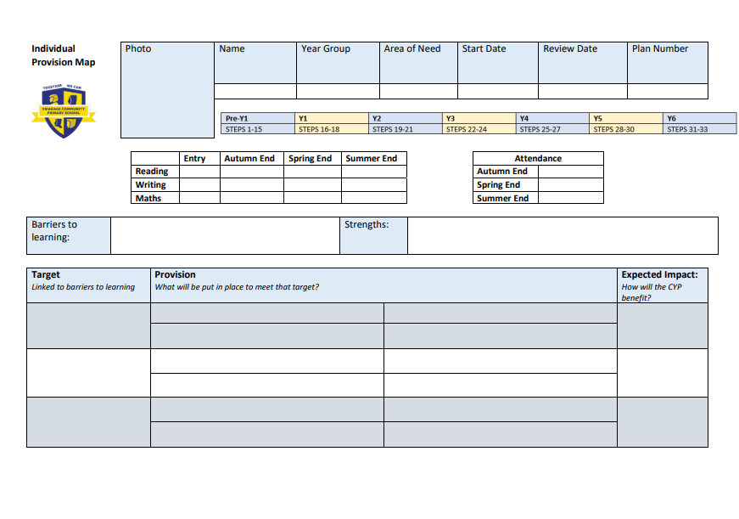
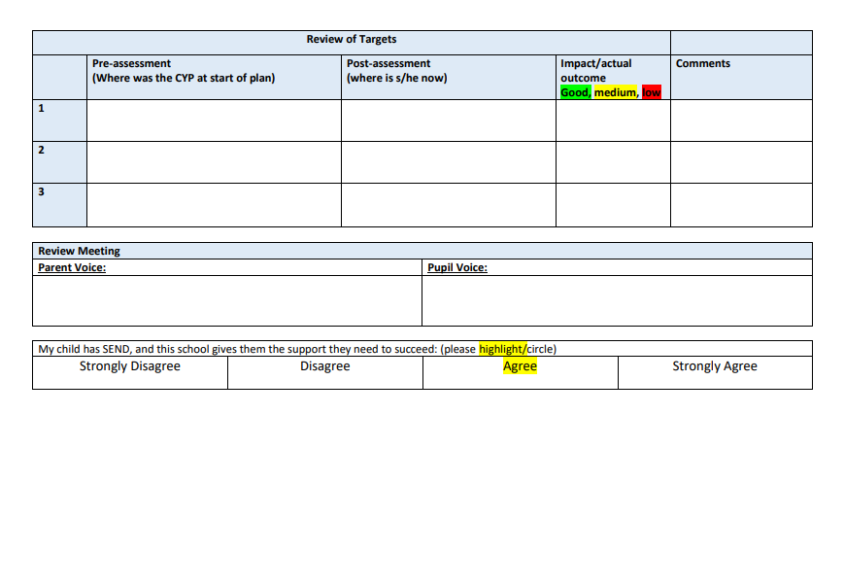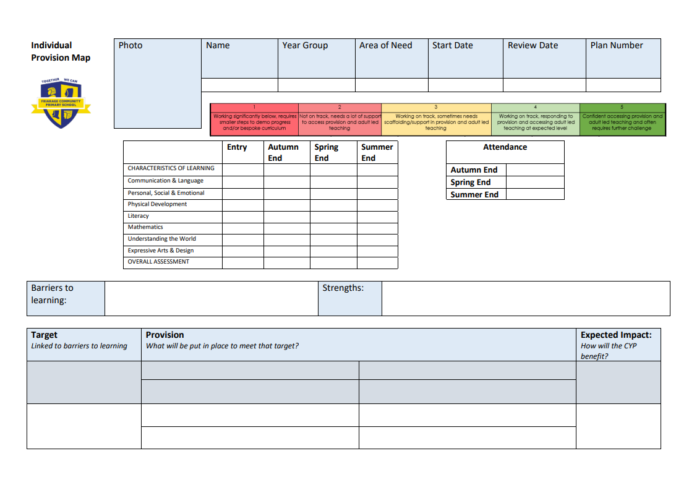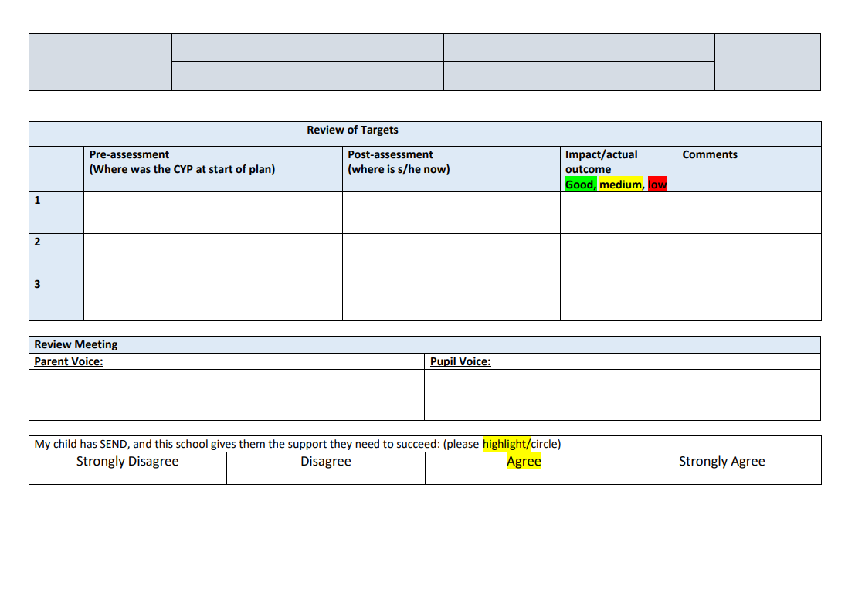

Appendix 2- Self-Harm Flow Chart
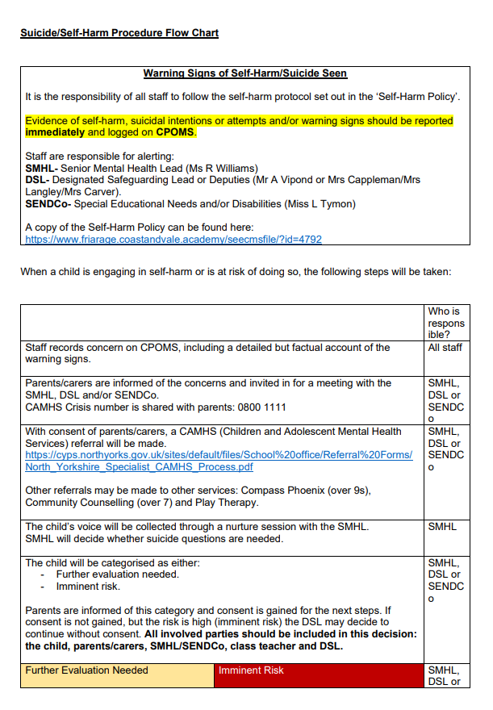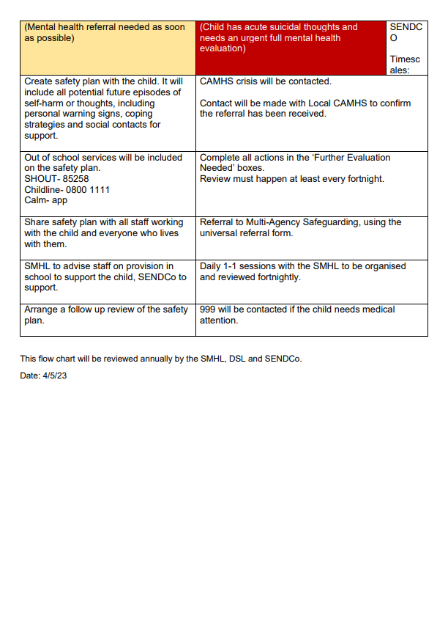
Appendix 3- How do we identify SEND?
