Home reading and phonics
Dear Parents/Carers,

Reading at home with your child regularly really helps them to make progress. This letter explains what you will find in your child’s reading folder.

Please make sure that your child brings their reading folder to school every day and that all books are returned. If you need a replacement book bag these can be purchased from the school office.

In your child’s folder you will find Read Write Inc storybooks:
These are books that your child has already read in school so is an opportunity for your child to read confidently with you. Your child should be able to read this book with little help. Please work on reading fluently and talk about the story with your child in order to develop their comprehension skills.

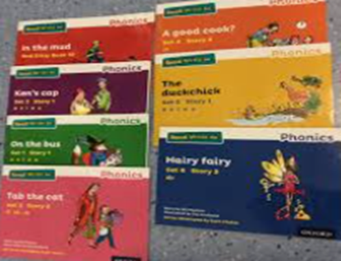

You will also find a Read Write Inc book bag books:

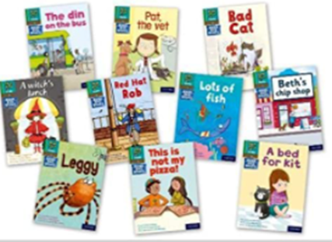
These books will be new to your child but only contain the sounds that they have learnt so is a good opportunity for your child to practise their decoding skills.

Each child has a log in to the Oxford Owl ebook library (https://www.oxfordowl.co.uk/) where your child can read their current Read Write Inc books as well as a selection of other ebooks. Please let your child’s teacher know if you need another copy of your child’s log in or any help accessing the books.

Your child will also have the opportunity to regularly choose a library book
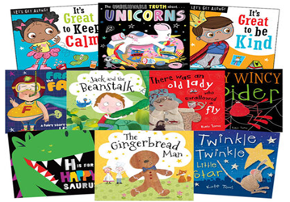
This is not a book that your child is expected to read but one that you can share together. Talk about the characters and setting. What do they love about the story? Is there anything that reminds them of another story? Can they predict what might happen next?
The most important thing however is to enjoy sharing the book together!

Please enjoy sharing books with your child as much as you can!

On top of this we may send your child home links to phonics lessons for your child to watch and practise at home. These links are sent home as QR codes. Simply scan the QR code with your phone to watch the video. The link will last for 10 days. This is a great opportunity for your child to revise and consolidate what they have been learning.

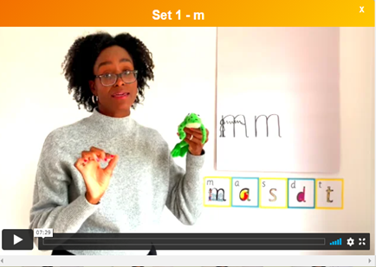

As ever please do get in touch with either myself or your child’s class teacher if you need any support with reading at home.

Thank you for your support,
Jenna Conner
Reading Leader

