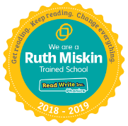
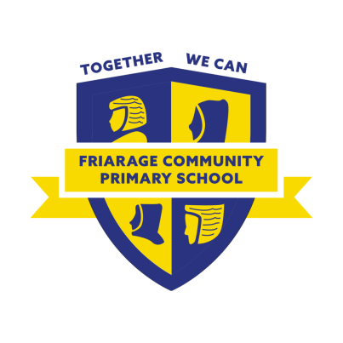
Friarage Community Primary School
Friargate
Scarborough YO11 1HS
Telephone: (01723) 374244
E-mail address: admin@friarage.n-yorks.sch.uk
Web: https://friarageprimary.org.uk
Head Teacher: Mrs C Cappleman
Deputy Head Teacher: Mrs Langley

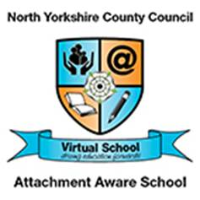

Harvest Festival 2020 Style

This year we will be having lots of individual celebrations. Each year group will take part in their own smaller Harvest Festival on Tuesday 20th October. This will be held in the school hall, unfortunately we are not able to invite parents/carers but we will be sharing photographs on our facebook page for you to see.

Please could you send any food contributions, e.g tins of beans, pasta, rice, teabags, vegetables etc to school on Monday 19th October. The produce will then be donated to the Rainbow Centre. Thank you in advance for your generosity in supporting this local charity.

